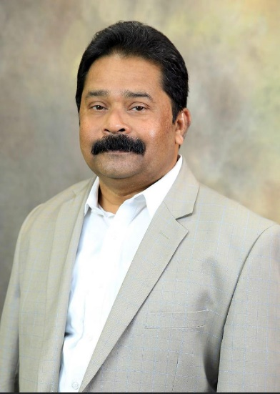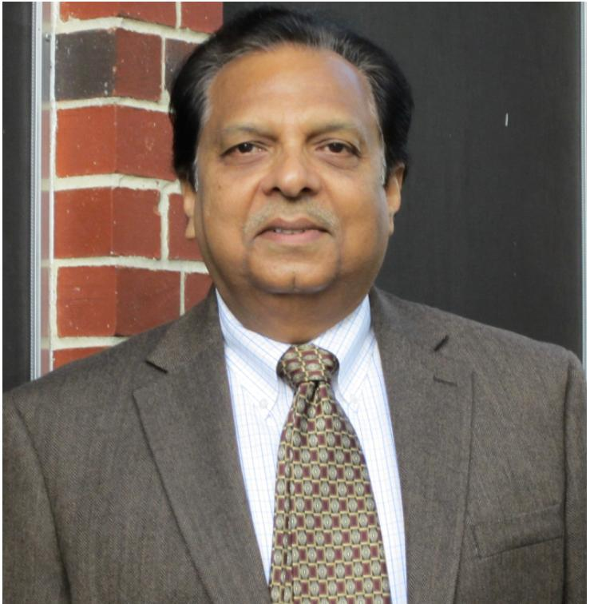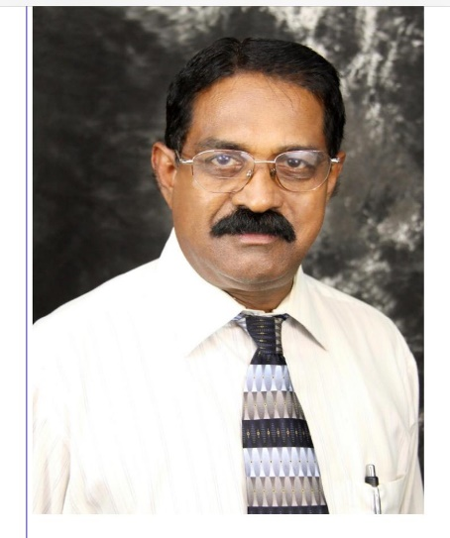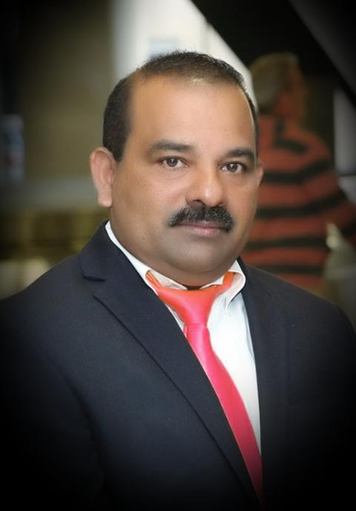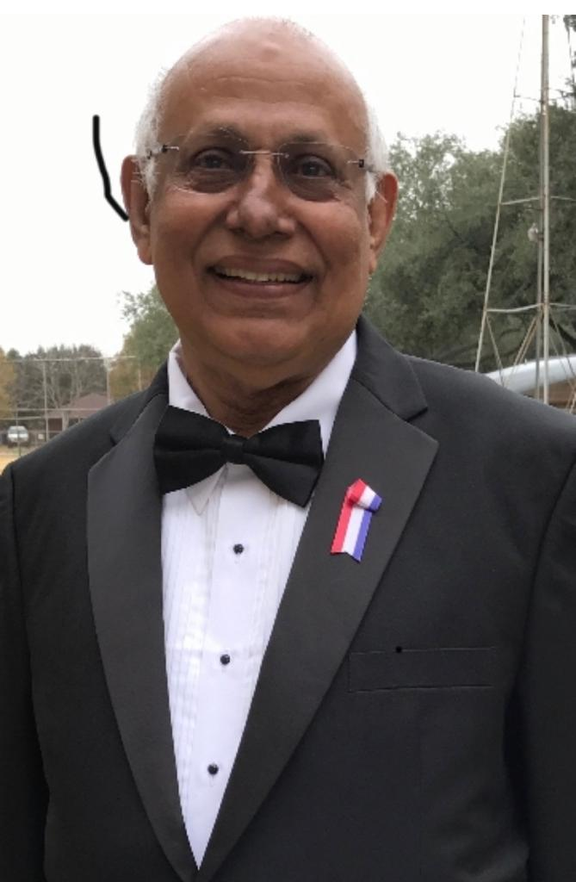

Thomas Oliyamkunnel – IOC (Kerala) - Houston Chapter President

Abrhaham Thomas – IOC (Kerala) - Houston Chapter Treasurer

Joseph Abraham – IOC (Kerala) - Houston Chapter Chairman

Baby Manakunnel Houston - IOC National VP

Vavachen Mathai IOC  
(Kerala) - Houston Chapter Gen Secretary

President